Application of Underwater Acoustic Remote Sensing
Examination of Flooded Penstocks, Tunnels and Water Intakes

Kenneth J. LaBry

Large industrial facilities, from utilities producing electricity to manufacturing plants and chemical refineries, all have the need to utilize water for either power generation or as a cooling source for the power sources and machinery of the mechanized automation they use to provide the product that is their reason for existence. Some, such as hydroelectric plants and other types of electricity producers, have more complicated water intake systems. The operation of the facility is dependent on a properly operating cooling system. To maintain the operational capacity and efficiency of the cooling system, the inlet conduit must be monitored and maintained. This requires that the maintenance staff be able to determine when the gradual degradation due to the wear of use, causes issues that require remediation and repair.

The periodic examination of these intake conduits should be inspected at regular intervals to document the progression of wear and degradation. Currently, Fenstermaker implements the only commercially operated sonar capable of imaging the internal wall of a flooded tunnel or conduit and providing a spatially referenced high resolution image of these water conduits. The acoustic sonar sensors were built at Fenstermaker’s request and to Fenstermaker’s specification by the sonar manufacturer, Kongsberg Mesotech. To adequately inspect these water conduits by other methods, such as a walk-through, requires de-watering of the conduit or pipe and presents significant safety issues relative to confined space operations. Due to the significant impact of these environmental conditions on results and findings as well as the safety of human participants, these surveys tend to be extremely subjective and provide poor spatial documentation of recorded observations. With the development of underwater acoustic imaging sonar systems based on steered beam sonar that can be articulated to project down a conduit, penstock, tunnel or pipe, there is now a methodology that can provide a comprehensive spatial element representation of flooded water conduit surfaces. The collected data can then be utilized for comparative analysis to previous examinations and utilized for predictive maintenance modeling.

The following example illustrates the benefits of utilizing robotic platforms and remote sensing for flooded penstock, conduit, tunnel, and piping. This case involves a 1000’, 10’ diameter vertical concrete penstock.

Typical Process
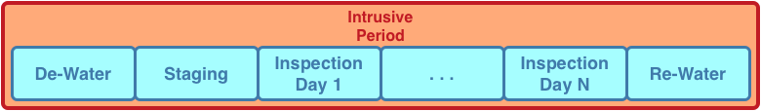
Fenstermaker Process

This methodology eliminates confined space worker exposure risk, heat exposure worker risk, contaminated air consequences for workers and associated risk, and de-watering structural destabilization risk. The methodology is also 85% less intrusive to operations and allows for examination prior to a scheduled outage where any necessary repairs can be anticipated and planned.

Robotics and remote sensing, when properly implemented, reduce human risk, reduce asset risk and provide valuable knowledge for conditional analysis and predictive maintenance modeling.

